TO WHOM IT MAY CONCERN

The following document is a map of the educational opportunities that Max Taylor, rising 10th grader has going forward to achieve a High School Diploma and choices to attend a Top Tier College oi University or take a professional career path based on his IQ, EQ, Problem Solving abilities and special talents/skills.

Max struggle throughout his 9th grade year at Charlotte Catholic High School. Most of the difficulty came from the transfer from a school where he was quite accomplished and entering a higher level academic school where Max had to adapt to the amount of work both in and out of the classroom. Once Max got fully engaged he took off, which did not happen till the second semester. Max’s attention to detail and desire to investigate STEM, Social Media and the Visual Arts grew from the time he entered high school till present day.

As a typical Boy high school student, Max needs help with organization, motivation and goal setting. What was interesting once we provided a tutor to Max in subjects he struggled with due to not being confident enough to ask for extra help through his teacher and the mentoring of IDFS, Max took off like a rocket ship. The analysis is Max needs Structure & more Structure but also needs to be able to engage in his interests globally as his questions and desires to learn he communicated showed Max is a head of most boys his age.

The following are the class Max is enrolled in at Charlotte Catholic High School next year (10th)

1. Mystery of Redemption
2. The Church: Sacrament of Salvation
3. Advanced English 10
4. Concert Band
5. Spanish 2
6. Advanced Algebra 2
7. Advanced Chemistry
8. World History

**\*\*\*\* All these class are College Prep except the 2 religion and one Performing Arts classes. Essentially 3 of Max’s courses meet the most rigor for a 10th grader at Charlotte Catholic but 3 courses are of no interest to Max and do not count toward college admission**.

After working with Max this past year on a weekly and sometimes multiple times a week, I would suggest that Max is a candidate for Ripping the Paper Ceiling ( using his IQ, EQ, Problem Solving and Special Talents to start a job/career in his field of choice rather than attend college ) or attend a College of max’s choice?

The following is my suggestion for Max for the next year while he is making a transition to another school and potentially living internationally in the Philippines.

Since Max will be in Charlotte or at least in the US for the first semester he needs flexibility so if he decides to go abroad he can transfer to a traditional high performing International school and attend on campus or continue with his online pursuits.

What we do know, which is undeniable is there is a significant difference in a College Prep, Advanced Placement and International Bacculaurate education in the US and Globally.

IB has become the US’ most rigorous approach to to high school curriculum because of its

Depth and Breadth and Extended Project/Essay required to achieve one’s diploma. For years the wealthiest families worldwide who wanted their kids to have the most options to attend college in any country made sure they studied IB not AP.

My suggestion for Max after several discussions with the Head of School, Dr. Michel Khoury, is to enroll in Eastwood Global On Line IB Programme.

Going forward starting between August 15 – September 1st, Max will enroll in Eastwood Global On Line and be tutored/mentored daily for at least 2 hours daily by one of IDFS’s contractors Lucas who tutored Max this past spring in Math and helped him master his math after falling down slightly early in the semester. Max achieved an A with the help of Lucas. Lucas has worked for IDFS and many of our clients who are now attending Top Tiers Colleges and Universities.

The reason Lucas will be available at least daily for 2 hours because transitioning to an on line education is difficult since the pacing in each discipline is determined by the student. We do not want Max to start of being in charge but instead IDFS will be determining the start and end time of each day. The question that needs to be answered is will Max be taking on line classes for the entirety of 10th grade or will he attend a traditional IB school in the Manilla in the spring?

If Max is going to be in an online curriculum all year then we will set Max up on Bock Schedule where he will be enrolled in 3 IB academic courses from September to Jan 1 and 3 more in the spring so Max only has to focus double time on 3 classes where he will finish a year in one semester. This approach is far more effective and allows for Internships and Travel.

Max has been offered an on site Internship with IDFS to start in September helping to set up Podcast interviews (Domestic & International Admissions, Undergraduate and Graduate Students, Department Chairs, Administrators etc.) and videoing some of the US’s top campuses – Harvard, MIT, Boston College, Tufts, Babson, Olin, Yale, Columbia, NYU, Bard, U Penn, Princeton, Johns Hopkins, Georgetown, GW, UVA, U Richmond, Duke, UNC, Georgia Tech and Emory.

There is a ton of interest in the world about the Anti-Semitism on each campus, Domestic and International Admission based on how the President is setting his tone and restrictions, Men in Girls Sports and so much more.

------------------------------------------------------------------------------------------------------------------

Welcome to Eastwood Global Online School, where we redefine education beyond traditional boundaries.

We are proud to be part of an elite group of just **seven schools worldwide** chosen by the [International Baccalaureate Organization](https://www.ibo.org/programmes/diploma-programme/dp-online/online-dp-pilot/eastwood-global/) to offer the prestigious **online International Baccalaureate Diploma Programme (IBDP).** In addition to the IBDP, we also provide an online school for Grade 6 to Grade 10, featuring a synchronous and asynchronous curriculum delivered by subject teachers. Our middle and high school curriculum follows the American educational system with a strong focus on IB preparation. This ensures flexibility and excellence in education for students **everywhere.**

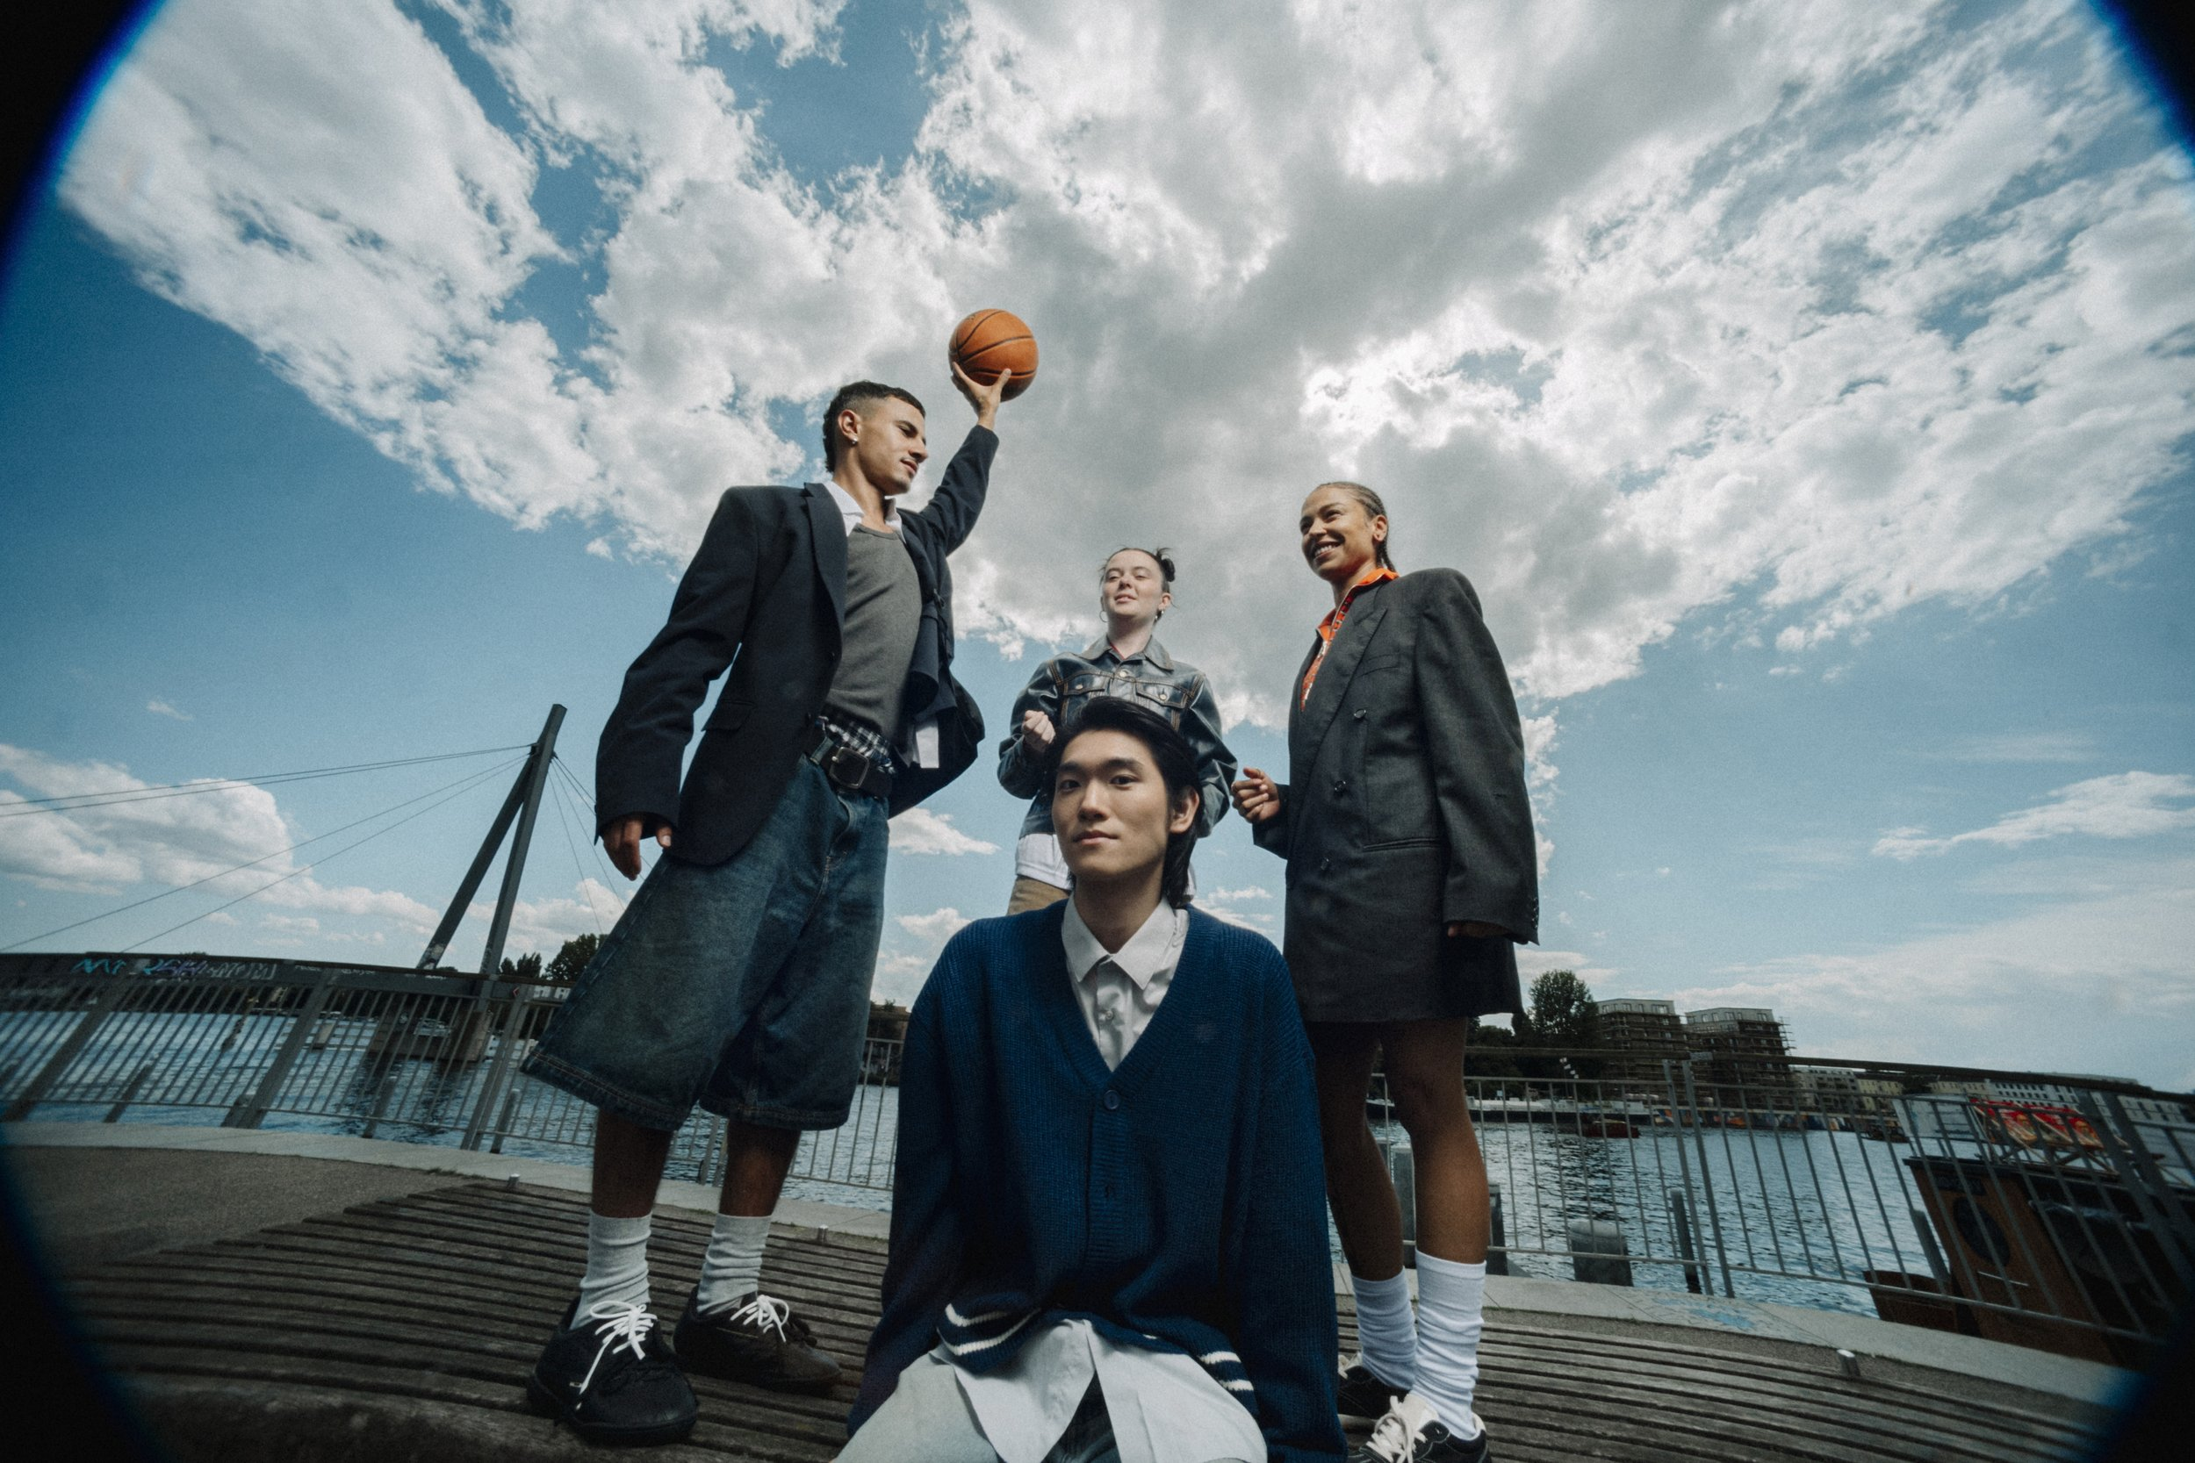

## ****What is the Diploma Programme?****

The [International Baccalaureate](https://www.ibo.org) (IB) [Diploma Programme](https://ibo.org/programmes/diploma-programme/) (DP) is a globally recognized, rigorous pre-university course for students aged 16 to 19. It challenges students to excel academically while developing critical thinking, research, and communication skills.   
  
The DP curriculum includes six subject groups, the Theory of Knowledge (TOK), the Extended Essay (EE), and Creativity, Activity, Service (CAS), fostering well-rounded, globally minded learners.   
  
Widely recognized by [universities and higher education](https://ibo.org/university-admission/) institutions around the world, the IB Diploma opens doors to academic and career opportunities, ensuring students are well-prepared for success in university and beyond.

LITERATURE/WRITING

Focuses on developing skills in **reading, writing, and analysis of literary and non-literary** texts in the student’s native or best language.

English A (SL/HL)  
Spanish A (SL/HL)  
Arabic A (SL/HL)  
French A (SL/HL)  
German A (SL/HL)  
Self-taught Language (SL)

SOC IAL SCIENCES

Explores subjects like history, economics, geography, and psychology, fostering an understanding of human behavior, societies, and global challenges.  
  
History (SL/HL)  
Economics (SL/HL)  
Business management (SL/HL)   
Psychology (SL/HL)  
Global Politics (SL/HL)

SCIENCE

Offers courses in biology, chemistry, physics, and environmental systems, emphasizing practical skills and scientific inquiry.  
  
Biology (SL/HL)  
Chemistry (SL/HL)  
Physics (SL/HL)  
Environmental Systems and Societies (SL/HL)  
Computer Science (SL/HL)  
Sports, Exercise, and Health Science (SL/HL)

MATHEMATICS

Develops mathematical reasoning and problem-solving skills, with courses tailored to different levels of ability and interest.  
  
Mathematics Analysis and Approaches  (SL/HL)  
Mathematics Applications and Interpretation (SL/HL)

VISUAL ARTS

Encourages creativity through courses in visual arts, music, theatre, and film, helping students express themselves and explore their artistic potential. (Optional)  
  
Visual Arts (SL/HL)  
Theater (SL/HL)

ENRICHMENT

Designed to develop critical thinking, independent research, and holistic personal growth, fostering well-rounded learners.  
  
Creativity, Activity, Service (CAS)  
Extended Essay (EE)  
Theory of Knowledge (TOK)

The **IB Diploma Programme** (IBDP) is at the heart of Eastwood Global’s academic offerings, preparing students to thrive in a complex and interconnected world. With a focus on **international-mindedness**, the IBDP develops critical thinkers, inquirers, and leaders of tomorrow.

Key elements of the program include:

• **Core Components**: Theory of Knowledge (TOK), Extended Essay (EE), and Creativity, Activity, Service (CAS), fostering well-rounded development.

• **Holistic Approach**: Subjects spanning six groups, including Language Acquisition, Sciences, Mathematics, and The Arts.

• **Global Perspective**: Skills and insights rooted in international-mindedness, promoting collaboration and cultural awareness.

Through the IBDP, students are equipped not only for academic success but also for life beyond the classroom—prepared to lead, innovate, and make a difference in the world.

At Eastwood Global, we bring the prestigious International Baccalaureate (IB) Diploma Programme to life through live, interactive classes led by expert IB educators. Designed for ambitious students seeking a world-class education, our program combines the flexibility of online learning with the dynamic engagement of real-time instruction.

Our students don’t just prepare for exams—they engage in deep, meaningful learning that nurtures critical thinking, collaboration, and global awareness. Through dynamic discussions, immediate feedback, and interactive group work, students sharpen the essential skills needed to thrive in the IB Diploma Programme and beyond.

**EASTWOOD GLOBAL   
ONLINE SA**  
Z.A. La Pièce 1  
CH-1180 Rolle  
Switzerland  
T. +41 21 805 05 91

**\*\*\*\*\*\* Once Max is in Manilla and wants to attend a traditional school the transition from Eastwood to Southville will be easy as the Programme is the same.**

**Why Study High School at Southville?**

The Southville Junior and Senior High School Division follow the National Curriculum of the United Kingdom for Science, Applied Science Common Core State Standards of the United States for English, Mathematics, Social Living, Global Education, and other subjects. It immerses students in a competitive research environment and develops their critical thinking, communication (written and verbal), interpersonal, and organizational skills. Engaging in research develops their lifelong love for learning and discovery of information that will constantly contribute to the ever-changing fields of the sciences, business, and the liberal arts. It also hones the students’ Financial Literacy and entrepreneurial mindset following the standards of financial capitals – New York, Singapore, and London. Students are guaranteed a competitive edge in their university life. This program is equipped with Interdisciplinary Learning: Relevant and Integrated Curriculum for High School.

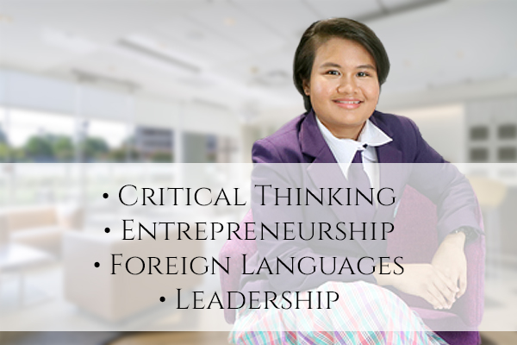

**Senior High School STRANDS  
Science, Technology, Engineering, and Mathematics (STEM)**

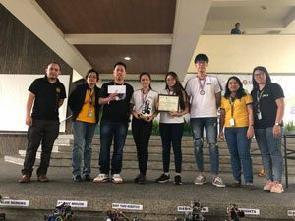

* Experimental P.A.S.S Research
* Language and Literature
* High-Level Math
* High-Level Science
* AI ICT
* Language Acquisition: Filipino, Mandarin, French
* EQ/ACT/Career Guidance
* Service Learning
* Elective: Biology, Physics, Robotics

**Accountancy, Business, and Management (ABM)**

Southville’s ABM program aims to d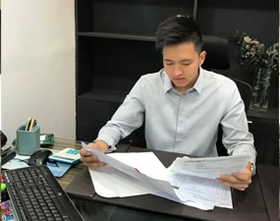evelop students’ critical thinking, strategic analysis, and decision-making skills to set their business management careers on the right track.

⦁ Business Plan Research  
⦁ Language and Literature  
⦁ Business Mathematics  
⦁ General Science  
⦁ Business Management  
⦁ Accounting  
⦁ Language Acquisition: Filipino, Mandarin, French  
⦁ Emotional Quotient / Achievers Core Training (EQ / ACT)/Career Guidance  
⦁ Service Learning  
⦁ Elective: Computer Education

**Humanities and Social Sciences (HUMSS)**

Southville’s HUMSS program enhances the student’s creativity, critical thinking skills, and concern for society as needed in careers such as mass media, history, social sciences, humanities, and others.

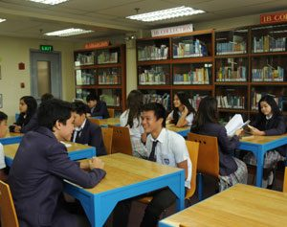

* Historical Investigation P.A.S.S. Research
* Language and Literature
* Math Studies
* General Science
* Social Sciences
* World Studies
* Introduction to Political Science
* Introduction to Psychology
* Language Acquisition: Filipino, Mandarin, or French
* Elective: Journalism, P.E. Art, Music
* Artificial Intelligence (AI) / Information Communication Technology (ICT)
* Career Guidance
* Service Learning

**General Academic Strand (GAS)**

Southville’s GAS program enhances the student’s creativity, critical thinking skills, and concern for society as needed in careers such as mass media, history, social sciences, humanities, and others.

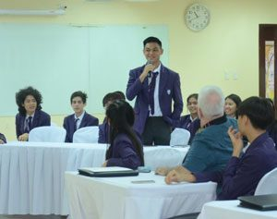

* Descriptive P.A.S.S Research
* Language and Literature
* Math Standard Level
* General Science
* Individual and Society
* Language Acquisition: Filipino, Mandarin, French
* Emotional Quotient / Achievers Core Training (EQ / ACT)/Career Guidance
* Service Learning